Civil war in Somalia

UNSC Resolution: | 746
Date of adoption: | 17-Mar-1992
Operative paragraph: | 3
Demand number: | 746,0311

Sarah-Myriam Martin-Brûlé

Wording of demand

cooperate with the Secretary-General and facilitate the delivery by the United Nations, its specialized agencies and other humanitarian organizations of humanitarian assistance to all those in need of it, under the supervision of the coordinator mentioned in resolution 733 (1992)

List of addressees of the demand

Government of Somalia, United Somali Congress Faction

Short-term compliance

Description of the addressee(s)’ conduct

In some cities, merchants in business partnership with powerful local warlords manipulated food prices
using large stocks of hoarded food. Rumours circulating among NGO workers had it that hoarded food stocks of tens of thousands of tons stolen from the relief effort were being maintained by the most powerful warlords. These rumours took on greater credence when the US military airlift was announced on the BBC. Overnight food prices dropped fairly dramatically in the cities these warlords controlled as merchants dumped hoarded food onto the market-place fearing their investment would loose value as soon as
the airlift was in full swing. Within a short time after the US military airlift was fully operational food prices dropped in most cities because these hoarded reserves were being released to the market." The airlift did not in fact increase the aggregate amount of relief food in the country as it merely
replaced an airlift being run by the ICRC and WFP. (The military flights limited by military procedure and security requirements did not carry the tonnage that the private flights did, and so while the number of planes in use increased, the tonnage moved did not.)12
http://pdfserve.informaworld.com/183299_751319779_784177267.pdf

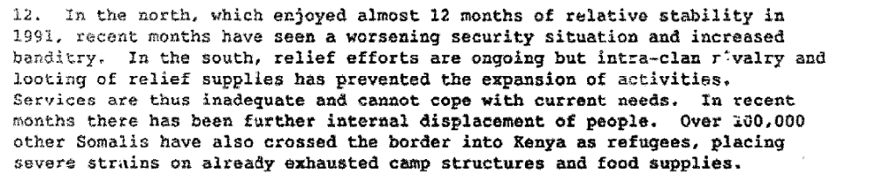

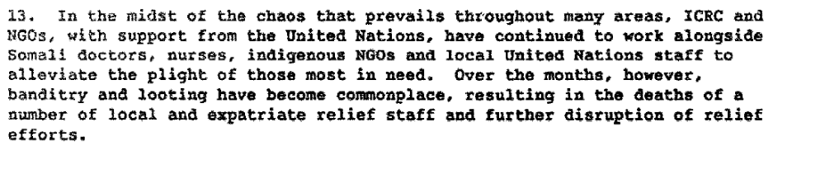

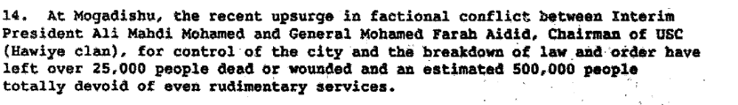

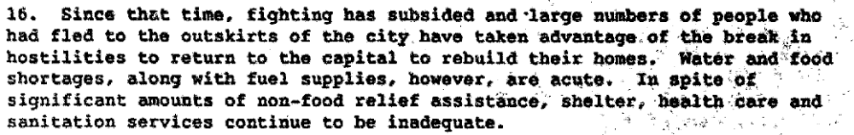

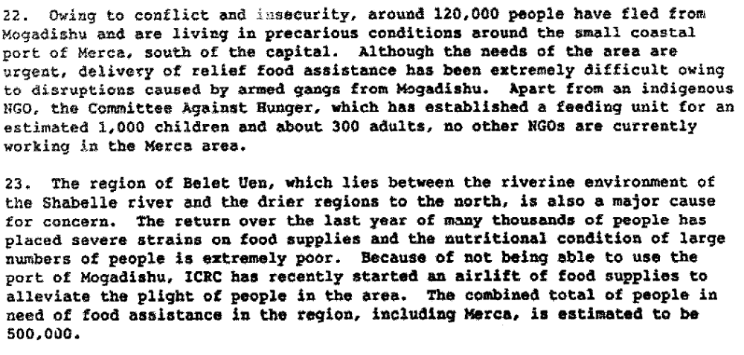

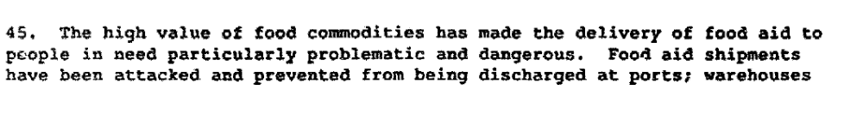

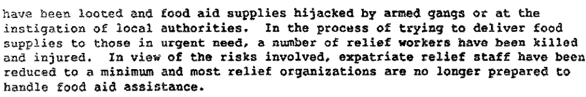

Report of the Secretary General on the Situation in Somalia, 21 April 1992 S/23829/Add.1

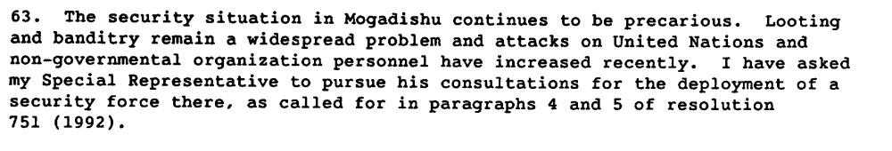

Report of the Secretary General on the Situation in Somalia, 22 July 1992 S/23434/

The director of the United States Office of Foreign Disaster Assistance, James R. Kunder, said after the visit to Mogadishu on Wednesday that the major barrier to helping the hungry was the continuing fighting between rival clans in Mogadishu, the Somali capital.
A greater effort had to be made, he said, to win agreement between the warring factions in Mogadishu to allow food already in the country to get to the people in need. Mr. Kunder's remarks were made at a news conference in Nairobi, Kenya, and made available in London by news agencies.
In telephone interviews, members of Mr. Kunder's team said that they had concluded that the fighting by heavily armed members of rival clans in Mogadishu was mostly over food and that hasty airlifts would only increase the level of fighting while the starving would still not get the food. Tens of Thousands Dead
Earlier this week, the United Nations Security Council approved an emergency airlift of food to Somalia, a mostly desert country of 4.5 million to 6 million people on the Horn of Africa. Tens of thousands of Somalis have died from the combined effects of war and drought in the last few months.
A special task force on Somalia was formed at the State Department this week under the leadership of Deputy Secretary of State Lawrence S. Eagleburger, officials said. The task force would decide what measures to take in Somalia after hearing from Mr. Kunder on his return to Washington on Friday, the officials said.
Because of the neglect of Somalia so far, officials said there would be a temptation to mount airlifts as a way of appearing to be doing something even though they may not achieve much.
Mr. Kunder, the most senior United States official to visit Mogadishu since the outbreak of civil war there 18 months ago, said, "People are dying in the thousands daily because aid workers cannot move relief food." He described the conditions in Somalia as "the single worst humanitarian crisis in the world."
"It is appalling that there is food at the Mogadishu port and at a store nearby but it cannot reach millions of starving people a few kilometers away because of the insecurity," he said. Urges U.N. Pressure
Mr. Kunder said the United Nations needed to pressure the two competing warlords of Mogadishu, Mohammed Farah Aideed and Ali Mahdi Mohammed, to insure that there was no further shelling of commercial ships coming into the port.
http://www.nytimes.com/1992/07/31/world/us-says-airlifts-fail-somali-needy.html

From his sparsely furnished offices in the south of this devastated and divided capital, Gen. Mohammed Farrah Aidid, a Soviet-trained military officer who lays claim to being the rightful leader of Somalia, spends hours every day stitching together the frayed loyalties of clansmen who demand food and loot in exchange for their allegiance.
Four miles away, past pot-holed streets lined with rubble, Mohammed Ali Mahdi, a mild-mannered hotelier who goes by the title Interim President of Somalia, drives from hot spot to hot spot in his northern enclave to negotiate, in a similar effort, with breakaway soldiers who mutiny for more money.
In spite of the daily battles within their groups, General Aidid and Mr. Mahdi are the strongmen of Somalia's chaotic clan-based society, each with the ability to call on more fighters, money and ammunition than anyone else in the land. The war between them has made it impossible to deliver food to regions hit by a famine estimated to have killed more than 100,000 since March. Threat to U.N. Troops
When the United Nations voted recently to send 3,000 soldiers to Somalia on top of the 500 already there but not deployed, the steely-eyed General Aidid threatened to send them home in body bags.
"We don't need outsiders," he said in a recent interview, attired in an open-neck shirt and slacks and grasping a silver-tipped cane. "With our own troops and a police force reconstructed with the help of the United Nations, we can look after the food. Since we have not been consulted in sending 3,000 troops to Somalia, it may be a matter of stabbing us."
The more conciliatory Mr. Mahdi said in an interview that he welcomed the United Nations forces, apparently believing their presence would give him an extra allure of power. He already lays claim to the Somali seat at the United Nations -- a claim that no other government recognizes -- as a sign of his power. Ex-Allies From Same Clan
"We need the United Nations forces, not only to protect the food," said Mr. Mahdi, who wears a safari suit as he drives around in the looted white Range Rover of the former British Ambassador. "We want the United Nations to give us a hand in collecting and buying the arms. To bring law and order we need outside force."
http://www.nytimes.com/1992/10/04/world/chaotic-somalia-starves-as-strongmen-battle.html

The main obstacle to improving the appalling plight of nearly two million hungry Somalis has been the looting by clan gangs, many of them led by General Aidid's men, of food destined for the starving.
If General Aidid does not challenge the American military, United Nations and other officials here said the task of opening the port and airport of Mogadishu for food deliveries and protecting convoys would be made much simpler.
http://www.nytimes.com/1992/11/28/world/us-plan-to-guard-convoys-is-backed-by-somali-general.html

Assessment

Short-term compliance
X No or marginal compliance (1) | Medium low compliance (2) | Medium high compliance (3) | Full or almost full compliance (4)

Considerations underlying the assessment

There has been marginal cooperation to facilitate the delivery of humanitarian assistance by the two parties.

Medium-term compliance

Description of the addressee(s)’ conduct

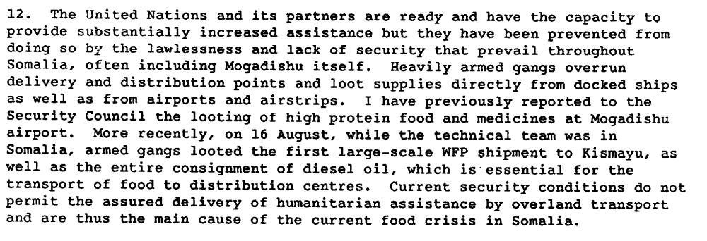

Report of the Secretary General on the Situation in Somalia, 24 August 1992 S/24480

Assessment

Medium-term compliance
X No or marginal compliance (1) | Medium low compliance (2) | Medium high compliance (3) | Full or almost full compliance (4)

Considerations underlying the assessment

Since both parties long benefitted from the looting of humanitarian resources, there has been no or marginal compliance with this demand.

Depth of demand

Assessment

Level of depth of demand
Low depth of demand (1) | X Medium depth of demand (2) | High depth of demand (3)

Considerations underlying the assessment
The survival of each group were not at stake yet their sources of revenues were jeopardize by such demand.

The chaos and relief effort together conspired unknowingly to create a set of pernicious incentives which simultaneously corrupted the natural instinct of the merchant class for some modicum of law and order, increased the demand for weapons and caused an increase in supply as their price rose, and reinforced the power of the most irresponsible elements of Somali society, the warlords, by providing them with more wealth, taken by extortion, protection rackets, and looting, for them to prosecute their clan wars and maintain their tenuous hold on power.14 Mohamed Sahnoun told me that he was not always certain that the warlords he was negotiating with were in control of the militias they led, or prisoners of them, given the lack of militia discipline and training. The tenuousness of warlord grasp on power put a premium on providing their militias with booty to keep their loyalty. Feeding the militias was not enough, the warlords were pressed to maintain their militias in the lifestyle to which they were accustomed.

Natsios, Andrew S.(1996)'Humanitarian relief interventions in Somalia: The economics of chaos',International
Peacekeeping,3:1,68 — 91

http://pdfserve.informaworld.com/183299_751319779_784177267.pdf

During this period, Somalia became known as the 'foreign aid graveyard,' because so much aid was siphoned off to the families and friends of corrupt government officials. Mohamed Osman Omar (note 7) pp.69, 88

Taw, Jennifer Morrison(2004)'The Perils of Humanitarian Assistance in Armed Internal Conflicts: Somalia in the
1990s',Small Wars & Insurgencies,15:2,5 — 19
http://pdfserve.informaworld.com/32673_770885140_791393639.pdf

Andrew Natsios, then-head of the US Office of Foreign Disaster Assistance (OFDA), who observed the efforts in Somalia first-hand, wrote of the pervasive effects of aid diversion on the local economy and balance of power: Food had become the medium of exchange and a principal source of wealth in Somalia. Because food was so scarce both from drought and civil conflict, its absolute value had risen to an extraordinarily high level. This factor combined with the collapse of the economy causing mass unemployment and a dramatic drop in family income increased the relative value of food. This meant food imported through the relief effort became an enormously attractive object of plunder by merchants, by
common working people without a source of income, by organized gangs of young men, and by militia leaders in need of the wealth represented by food aid which they would use to purchase more
weapons and ensure the loyalty of their followers.34 Much of the aid leakage benefited the warlords directly, particularly Ali Mahdi and Mohammed Farah Aidid in Mogadishu. Natsios decried this,
explaining that:
Pouring food into this unnatural and corrupted economic system would
do more harm than good without a dramatic change in the security
situation. It would reinforce the power of the warlords by giving them
more wealth with which to keep their followers loyal, purchase more
weapons, and capture the loyalty of other unallied clans.35

Alex de Waal wrote equally damningly of the leakage, claiming that relief
agencies played 'the role of quartermaster to armies.'36

Taw, Jennifer Morrison(2004)'The Perils of Humanitarian Assistance in Armed Internal Conflicts: Somalia in the 1990s',Small Wars & Insurgencies,15:2,5 — 19
http://pdfserve.informaworld.com/32673_770885140_791393639.pdf

Level of confidence about coding decisions

Level of confidence about coding decision
Extremely high | X High | Moderate

Comments to IPI (if any)

